Newsletter for St Brendan, Harwood, St Columba, Tonge Moor
& St John the Evangelist, Bromley Cross

23rd November 2014
Our Lord Jesus Christ, King of the Universe

He will take his seat on his throne of glory, and he will separate men one from another
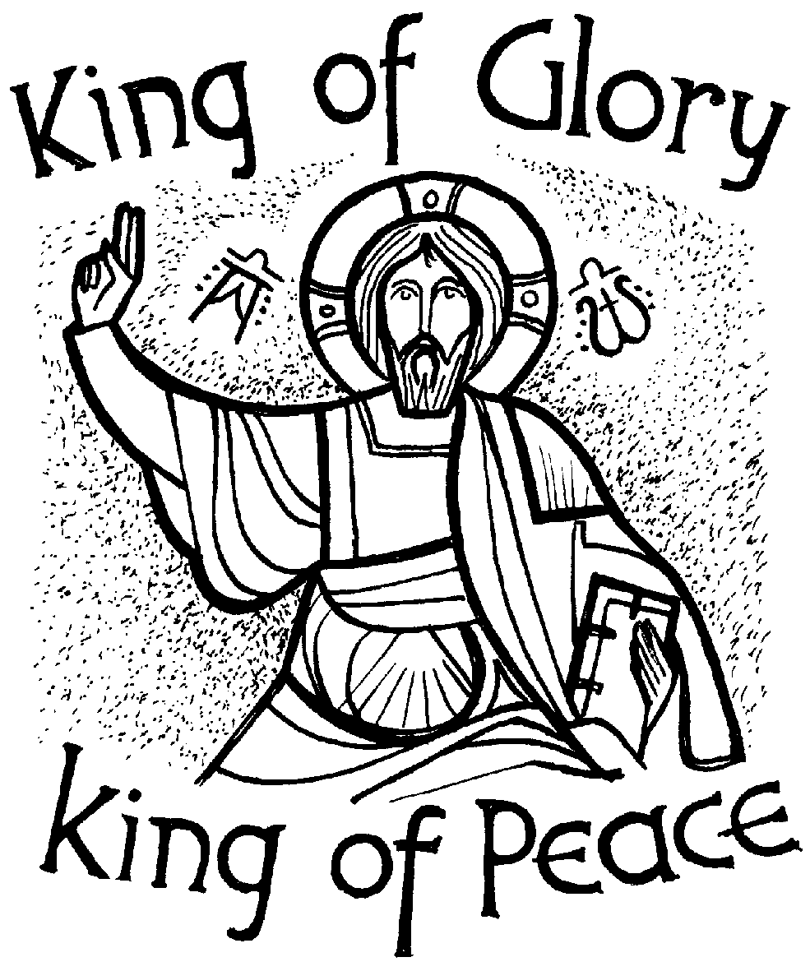Shepherd-King o’er mountain steep, homeward bring the wandering sheep. This hymn which we will probably sing today captures the readings perfectly: our King is not a cruel tyrant or despot, but a shepherd who loves his flock, who would (and did) give his life for them. Love for the flock means that he will have to judge them, separating the sheep from those who do not belong to him. Coming to the end of the Church’s year leads us to look to our final ending, the homecoming the hymn speaks of. The judgement of the end of time we do not view as a trial or a terror, but as a coming home: look back to the Isaiah reading on the 28th Sunday to see what a homecoming party is offered. All we do is put our lives in order, living just and holy lives, longing for the day of the Lord to come.

.Liturgy & Activities This Week  Sunday Cycle A; Weekday Cycle 2; Divine Office Week 2  Sunday Missal: page 514 Preface: page 523 |  | Prayers Please  Sick: Gladys Hall, Kevan Dunleavy, Mary Leigh, Joan Coles, Isabelle Owen, Laura Shuttleworth, Tony Winstanley, Eunice Brierley, Cecilia Guest, Bernard Holder, Eileen Murphy, Kathleen Hopwood, Maureen Kennedy, Joan Pearce, Peter Cranmer, Anthony Axford, Pauline Bowling, Caroline Garside, Sarah Parkinson, Mary Long, Dylan Crosby, Pat Hall, Linda Southern, Mary Joan Tornai, Bernard Neyland and all who are sick or recovering from serious illness.  Lately Dead: Liz Alderson, Irene Allen, Joy O’Sullivan, Margaret Parkinson, Joseph Bryan  Anniversaries: Sheila Mason, Graham Taylor, John Meagher, Francis Xaiver Price, Winifred Meagher, Len Wallwork, Florence & Louis Hodgkinson, Eva Sheridan, Terry & Nell O’Neill, Mary Coyne  Mass Intentions: Sheila Mason, Liz Alderson, Graham Taylor, John Meagher, Francis Xaiver Price, Winifred Meagher, Len Wallwork, Patrick Plunkett (Birthday Remebrance), Florence & Louis Hodgkinson, Majella Halstead (For a major operation), Eva Sheridan, Irene Allen, Terry & Nell O’Neill  Bishop John Arnold: Please keep our new bishop in your prayers over the coming weeks as he prepares to move to Salford and take up this new role in his ministry of service to the church  Cycle of Prayer Part 6 (of 6):We pray especially for: the spread of the Gospel; the harvest; the fruits of human work & the reverent use of creation; justice and peace in the world; all victims of war; young people; prisoners & their families
Sunday | 9.15am Mass (SJ) - with Children’s Liturgy  10.15am Mass (SC) - with Children’s Liturgy  11.15am Mass (SB) - with Children’s Liturgy  A Special Day of Prayer for Young People
Monday  St Andrew Dung-Lac | 9.30am Mass (SJ)  7.45pm SVP (SJ)  34th Week of Ordinary Time
Tuesday | 7pm Mass (SB)  7pm Passion for Bolton Prayer Meeting (Parish Church)  7.30pm SVP (SB)
Wednesday | 9.30am Mass (SJ)  1.30pm-3pm Harbour Room Book Club (SB)
Thursday | 9.15am Mass (SB)
Friday | 9.30am Mass (SJ)  11.30am Funeral Service for Joseph Bryan (SC)
Saturday | 11am Mass for the Deceased (SC)  2pm Baptism (SJ)  5pm Mass (SC)  5.30pm-6pm Reconciliation (SJ)  6.30pm Mass (SJ) A Special collection for CARITAS Diocese
Next  Sunday  St Andrew, Patron of Scotland | 9.15am Mass (SJ) - with Children’s Liturgy of Salford  10.15am Mass (SC) - with Children’s Liturgy  11.15am Mass (SB) - with Children’s Liturgy  2pm Baptism (SC) First Sunday of Advent
Collections & Donations: All cheques (even for special collections) should be made payable to St Brendan’s, St Columba’s or St John’s as appropriate.
Mass Intentions: Cheques should be made payable to St John’s
Gift Aid: If you are a tax-payer, the parish can claim back the tax you have paid on any donations you make if you simply sign a Gift Aid form once. Please ask. Thanks

Congratulations: To Thomas George Davison who was baptised at St Brendan’s last Saturday. We pray that he and his family may continue to grow in faith.

CARITAS: As we begin to make our preparations for Christmas, it is good to think about those in need, as we are doing locally through BRASS and Urban Outreach. Next weekend we will have a special collection for CARITAS Diocese of Salford which combines a number of care services for children, families and vulnerable people in our community. This collection was deferred from earlier in the year. Please be as generous as you can be.

Ebola: CAFOD, as part of the Disasters Emergency Committee, is appealing for donations to help combat the effects of the Ebola crisis. They are running an education programme about prevention, training people to assist with healthcare and providing food for communities that are cut off by this crisis or where people are unable to work. Rather than having a further special collection, our parish CAFOD group would welcome any private donations. Please put these in an envelope and hand it in when you come to church. Thanks

CAFOD World Gifts: Have you ever thought of giving someone a chicken, a cow or a queen bee for Christmas? CAFOD World Gifts are alternative gifts that make a world of difference. They do something no pair of socks can, they change lives around the world. If you would like more information, please speak to a member of the CAFOD Group or visit www.cafod.org or pick up a catalogue.

Cameo Group: Wednesday`s talk on the History of Barrow Bridge was great. Many of those who attended had memories they could add to Mike’s. A donation of £25 was given to Mike in aid of Christians against Poverty at St Peter`s, Halliwell. Cameo also made a donation of £200 towards the redecoration of the Harbour Room. Thank you to everyone! Event for 2015: Wednesday 14 January - Post Christmas Fun and Games. Details to follow.

Harbour Room Book Club (SB): The next meeting is on Wednesday 26 November. (1.30-3pm) to discuss Fighting on the Home Front by Kate Adie. Refreshments and all welcome.

Advent Evening of Recollection for Men: Tuesday, 25 November 2014, 7.30pm - 9.30pm. This will be a “mini-retreat” for men at St Mary’s Church, 86 Chorley New Road, Horwich BL6 5QJ led by Fr Peter Bristow from the Manchester Opus Dei Centre.. Further information from Robert Aston Tel. 01204 468896

The Parish Quiz: Thank you to everyone who came along to the Quiz Night last Friday. It was a fantastic evening and lovely to see so many from each of our churches. Don’t forget, that coming up, there are going to be more opportunities for us to have a get together.

Gates [SB]: Parishioners are reminded that on weekdays during school term from 7.30am to 6pm approx, both the vehicle and pedestrian gates are to be left unlocked and open so that pedestrians can safely avoid using the vehicle entrance. Out of term times both gates should be closed and locked apart from when services are taking place.

Church Cleaning (SJ): J Burton & H Bradbury
Advent & Christmas

Walk With Me: The booklets and calendars for Advent are now available – free of charge. Do please take one home and use it to help your prayer during this season of preparation for Christmas.

St Columba’s Christmas Fayre: Sunday 7 December. Christmas Draw tickets are now on sale.

St John’s Christmas Draw: Tickets are on sale. Prizes will be gift vouchers only. Anyone wishing to donate a voucher of any value will be very welcome.

CAMEO Group: Wednesday 10 December (2pm-4pm) in the Harbour Room (SB). Christmas Flower decorations by Margaret Fazackerley Please bring Ivy or Holly and if you have one, a bowl for the decoration.

Christmas Coffee Morning: Friday 12 December after 9.30am Mass at St John’s Church. All proceeds will go to Urban Outreach. A warm welcome to all!

Parish Christmas Dance: Friday 19 December at
Dunscar Conservative Club. Tickets Now on Sale!

Urban Outreach
Urban Outreach is planning to provide Christmas Dinner on Jesus to 1000 nominated individuals and families around Bolton who find this time of year difficult. This is a complete Christmas Day meal in a box including the chicken, vegetables, crackers and chocolates and much more. This brings the love of Jesus into so many homes in a practical way!

How we are helping:
Churches in Harwood are collecting 1000 packets of savoury crackers (200-300grams). St Brendan’s need to collect 300 on the first two weekends of December.
Our SVP are nominating some households in our area to receive the hampers and our three schools are also planning to contribute to this initiative.

If you would like to help by either donating items or money or volunteering to help pack & give out the hampers (17-23 December) then please contact Hannah Matthews, Local Welfare Provision Coordinator, Urban Outreach (Bolton), Environ House, Salop Street, Bolton BL2 1DZ. Tel: 01204 385848) christmasdinner@urbanoutreach.co.uk

Think Vocation
Let us rejoice on this feast day of the Catholic faith that is celebrated in every country of the world. We pray for young people to be proud of their faith and recognise that they belong to a Church where people of every nation, culture, race and language can praise Christ as their universal king.

